RESUME 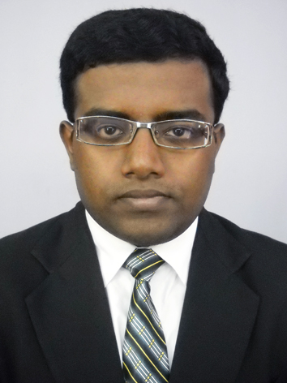
Name: TIRTHA MAJUMDER
Address: 1/3 SAHID NAGAR,
KOLKATA-700031(WB)
Mobile no.- 9903087721
MAIL :- tirtha202@gmail.com

OBJECTIVE
To have well-rounded skills in development and looking forward to pursue a much highlighted career and to utilize my skills and abilities in the industry and to plan and execute within a time frame by blending human resource and systems, so as to keep pace with business, competition and services.
SUMMER TRAINING DETAILS:_____________________________________________________________________
Company : Sahara India Pariwar
Position :Summer Trainee
Period of work : 1st May, 2014 to 1st July 2014
Project Details Topic- Talent acquisition process

INTERNSHIP SUMMARY

- Comprehensive knowledge of full recruitment life cycle and processes
- Familiar with job market, web-based and Internet recruiting techniques.
- Ability to interface and maintain good working relationships with individuals at all levels
- Skilled in using Microsoft Office like Word, Excel and the Internet. Ability to work in a result and target-oriented and fast paced working environment
HIGHLIGHTS OF EFFECTIVENESS IN THE FOLLOWING AREAS:

Recruitment, Resourcing and Development
- Identifying future manpower requirement and designing plans for acquiring requisite skills and competencies
- Overseeing all aspects of recruiting, right from understanding profile through Job portals and Advertisements.
- Responsible for developing and executing effective methods to identify, source, assess and attain qualified candidates for the organization
- Coordinating with peers and hiring managers to define talent needs, construct and execute plans to fulfill the requirements.

academic qualification

EXAMINATION | BOARD/UNIVERSITY | YEAR | PERFORMANCE
Diploma in Management(BBA) | IIPM | 2015 | 67.67%
Advance Diploma in Human Resources | ISBM | 2016 | 56%
Higher Secondary 12th | ICSE | 2012 | 72%
Secondary 10th | ICSE | 2010 | 58%

Employment chronicle

APRIL 2015 – Till Date ▪ Hr Executive ▪ Corp Bounty Hr Services ▪Kolkata

It skills
Well versed with MS Office; Internet savvy.

EXTRA CURRICULAR ACTIVITIES & HOBBIES
- Reading books & Listening to music

personal dossier
Date of Birth: 10-10-1993
Father’s Name: Gopal Ch. Majumder
Languages Known:English, Bengali and Hindi
References: Available on Request

Date:
Place: Kolkata Signature

